Monitoring (Prometheus + Grafana) on AWS

**Prometheus** = monitoring system

**Grafana** = the front end

# Building Docker image of Prometheus & Deploy

1. Create EC2 instance
   1. T2 Micro
   2. Fix incoming traffic patterns (All traffic, IP4 & All traffic, IP6)
2. Get public IP & put it in PuTTY along w/ PPK key
3. PuTTY commands:
   1. Sudo apt update
   2. Sudo snap install docker
   3. Sudo docker pull prom/prometheus
   4. Sudo docker network create network
   5. Sudo docker volume create prometheus-data
   6. Vi Prometheus.yml
      1. Insert into the yml file:
         1. 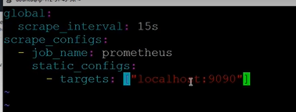
   7. 
4. Get the DNS & paste it into the browser along with the “:9090” port
   1. Brings up the Prometheus UI
5. Prometheus UI:
   1. Click on Status, Targets to see metrics for the endpoint
   2. Click on Graph
      1. When you start to type, it brings up all of the parameters you can see graphs of on the screen
      2. Select one & click Execute button
      3. 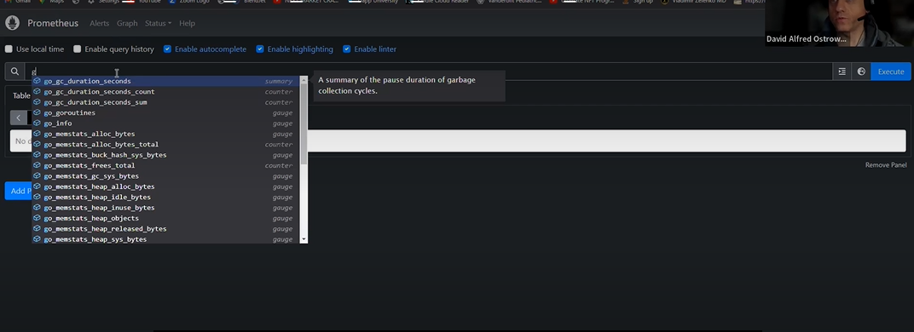

# Building Grafana UI

1. Create another PuTTY instance
2. PuTTY commands:
   1. Sudo docker pull grafana/grafana
   2. Sudo docker volume create grafana-data
   3. Sudo docker container run -v Grafana-data -p 3000:3000 --name grafana --network network grafana/grafana
3. Login to Grafana GUI
   1. Grab DNS + “:3000” port name & paste it into the browser
   2. Brings up login
      1. Username = admin
      2. Password = admin